Descriptive Grammar

🔹 What is Descriptive Grammar
# Source: AI Source: Provided by: [Data Path: Persons Table -> ID Column: 1, Name_En Column: Motasem Essam] -> From: [Chatgpt (GPT-4-turbo)] on [8/3/2025]
Descriptive grammar refers to the set of rules and patterns that describe how language is actually used by speakers and writers in real-life situations—not how it "should" be used.
It does not judge correctness but instead observes and records language as it is spoken and written, even if it's informal or nonstandard.

✅ Key Features of Descriptive Grammar:
# Source: AI Source: Provided by: [Data Path: Persons Table -> ID Column: 1, Name_En Column: Motasem Essam] -> From: [Chatgpt (GPT-4-turbo)] on [8/3/2025]
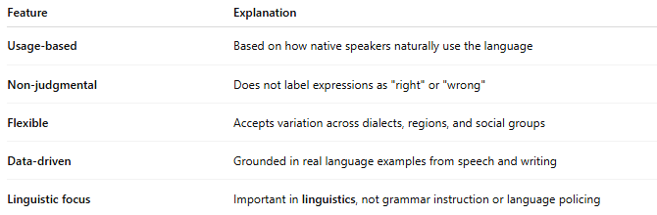
Feature | Explanation
Usage-based | Based on how native speakers naturally use the language
Non-judgmental | Does not label expressions as "right" or "wrong"
Flexible | Accepts variation across dialects, regions, and social groups
Data-driven | Grounded in real language examples from speech and writing
Linguistic focus | Important in linguistics, not grammar instruction or language policing

✅ Examples of Descriptive Grammar in Use:
# Source: AI Source: Provided by: [Data Path: Persons Table -> ID Column: 1, Name_En Column: Motasem Essam] -> From: [Chatgpt (GPT-4-turbo)] on [8/3/2025]
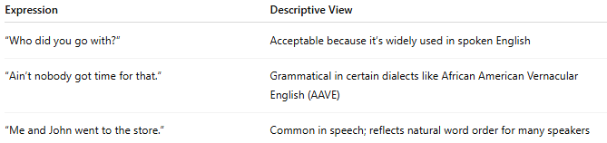
Expression | Descriptive View
“Who did you go with?” | Acceptable because it’s widely used in spoken English
“Ain’t nobody got time for that.” | Grammatical in certain dialects like African American Vernacular English (AAVE)
“Me and John went to the store.” | Common in speech; reflects natural word order for many speakers

✅ Descriptive vs. Prescriptive Grammar:
# Source: AI Source: Provided by: [Data Path: Persons Table -> ID Column: 1, Name_En Column: Motasem Essam] -> From: [Chatgpt (GPT-4-turbo)] on [8/3/2025]
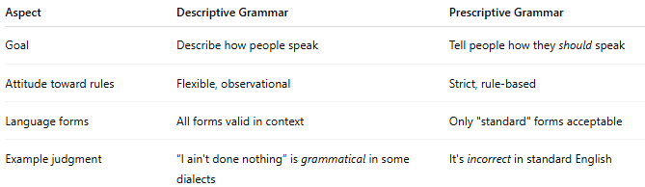
Aspect | Descriptive Grammar | Prescriptive Grammar
Goal | Describe how people speak | Tell people how they should speak
Attitude toward rules | Flexible, observational | Strict, rule-based
Language forms | All forms valid in context | Only "standard" forms acceptable
Example judgment | “I ain't done nothing” is grammatical in some dialects | It's incorrect in standard English

✅ Why Descriptive Grammar Matters:
# Source: AI Source: Provided by: [Data Path: Persons Table -> ID Column: 1, Name_En Column: Motasem Essam] -> From: [Chatgpt (GPT-4-turbo)] on [8/3/2025]
- Respects dialectal diversity
- Aids in understanding language change and variation
- Forms the foundation of linguistic analysis
- Helps teach English as it’s used, not just as it's taught

📝 Summary:
# Source: AI Source: Provided by: [Data Path: Persons Table -> ID Column: 1, Name_En Column: Motasem Essam] -> From: [Chatgpt (GPT-4-turbo)] on [8/3/2025]
- Descriptive grammar = What speakers say
- It is descriptive, not prescriptive
- Valuable for linguistics, language teaching, and understanding real-world communication

